
SCHOOL OF TECHNOLOGY
DATABASE MANAGEMENT SYSTEMS (DBMS) COURSE PROJECT REPORT
DINEDESK: RESTAURANT RESERVATION, REAL-TIME DINING & BILLING MANAGEMENT SYSTEM
SUBMITTED BY:
Student Name : Sakhunala Sahaja
Roll Number : 25WU0102237
Course : CS301 - Database Management Systems Laboratory
UNDER THE GUIDANCE OF:
Faculty Name : Dr. Kiran Mayee
Academic Year: 2025 – 2026

2. Abstract
Modern culinary establishments face immense logistical bottlenecks when coordinating tableside dining experiences, including table allocation overbooking, fragmented kitchen-line communications, disjointed item level billing, and data loss during customer draft sessions. DineDesk is an enterprise-grade, relational database-driven Fine Dining & Lounge Management System engineered to bridge the disconnect between patrons, executive kitchen brigades, and front-of-house staff.
Built on a third-normal-form (3NF) relational architecture using SQLite and PostgreSQL, with high-performance asynchronous RESTful APIs (FastAPI/Python) and a luxury responsive frontend client, DineDesk delivers real-time concurrency-safe table locking, synchronized time-slot reservations (with advance scheduling validation), item-stepper synchronized cart ordering with persistence, real-time live kitchen preparation stage trackers, and automated promotional discount & GST billing computations. This report details the complete engineering lifecycle of the DineDesk platform, including Entity-Relationship modeling, normalization proofs, schema definitions, DDL/DML scripts, complex analytical queries, system architecture, comprehensive test matrices, and future evolutionary enhancements.

3. Introduction and Problem Statement

3.1 Introduction
Hospitality enterprises operate in high-velocity environments requiring millisecond synchronization across seating zones, dietary dietary-restricted menu catalogs, synchronized live kitchen queues, and tableside invoicing. Traditional restaurant operations suffer from manual paper slips, disconnected point-of-sale registers, and uncoordinated floor management.

3.2 Problem Statement
Contemporary dining software platforms exhibit critical structural limitations:
1. Concurrency Conflicts: Multiple customers booking identical table nodes simultaneously during peak slots without atomic transaction isolation.
2. Lack of Atmosphere-Aware Allocation: Inability to filter tables dynamically by distinct ambiance zones (Romantic Rooftop, Main Dining Hall, Family Lounge, Private Dining Suite).
3. Client State Evaporation: Unsaved customer reservations, cart items, notes to chefs, and promo discount selections being lost upon accidental browser reload.
4. Kitchen-to-Table Blindspots: Lack of granular multi-stage progress tracking (Order Received -> Cooking in Progress -> Plating & Quality Check -> Served Tableside).
5. Financial Inaccuracies: Erroneous multi-tier tax computations, discount capping failures, and unanchored billing states.

4. Objectives and Scope

4.1 Primary Objectives
• Design and normalize a robust relational schema up to 3NF/BCNF enforcing strict entity and referential integrity.
• Develop automated RESTful CRUD microservices for floor seating, menu cataloging, dining sessions, orders, and payment receipts.
• Enforce business rules at the database level: foreign key cascades, unique table constraints, timestamp range queries, and reservation lead-time guarantees.
• Provide an intuitive, responsive frontend with persistent state caching, dynamic filtering, locked table indicators, and kitchen progress visualization.

4.2 Scope of the Project
The project encompasses the complete operational spectrum of a multi-area fine dining establishment, including customer identity verification, interactive table floor mapping, categorized culinary catalog browsing with dietary tags (Veg, Vegan, Chef Special, Gluten-Free), item quantity steppers, real-time order dispatching to kitchen stations, tableside live order tracking, promo code redemption, and digital multi-mode receipt generation.

5. Software and Hardware Requirements
Category | Requirement | Specification / Version | Role in DineDesk
Software | Operating System | Windows 10 / 11, Linux (Ubuntu 22.04+), macOS | Host runtime environment
Software | Database Engine | SQLite 3.39+ / PostgreSQL 15+ | Relational data persistence & transactional integrity
Software | Backend Framework | Python 3.10+ / FastAPI 0.109+ / Uvicorn | Asynchronous API layer & database ORM mapping
Software | ORM / Driver | SQLAlchemy 2.0+ / Alembic | Object Relational Mapping & schema migrations
Software | Frontend Architecture | HTML5, Modern CSS3 (Glassmorphism), Vanilla ES6+ JS | User client with responsive luxury interface
Hardware | Processor | Intel Core i3 / AMD Ryzen 3 or higher | Backend execution and query processing
Hardware | RAM | 4 GB Minimum (8 GB Recommended) | Server processes and browser rendering
Hardware | Storage | 500 MB free disk space | Database files, server assets, food photography

6. Entity-Relationship (ER) Diagram
The DineDesk database architecture models 9 primary entities connected through foreign-key relationships. Below is the Entity-Relationship structure and cardinality mapping:
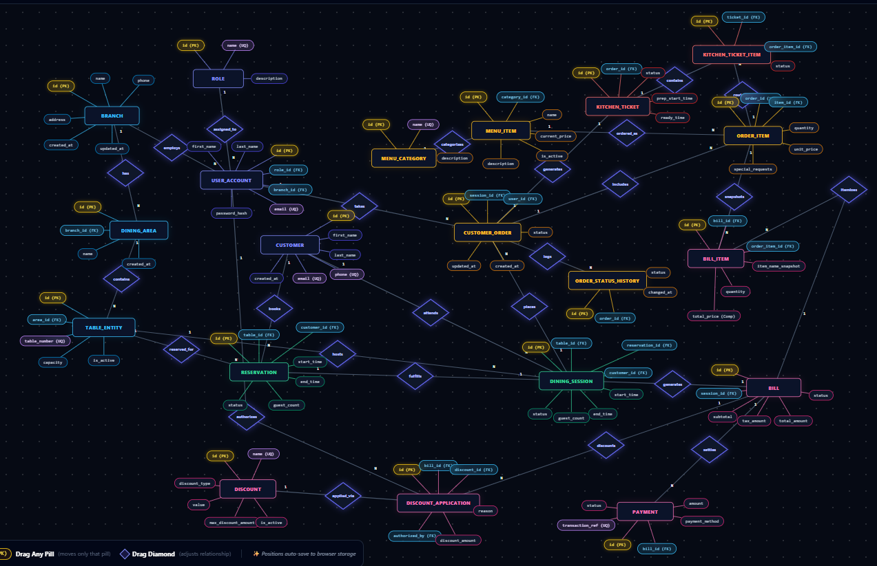

7. Relational Schema and Normalization

7.1 Relational Schema Representation
1. BRANCH (id [PK], name, address, phone, created_at, updated_at)
2. DINING_AREA (id [PK], branch_id [FK->BRANCH.id], name, created_at, updated_at)
3. TABLE_ENTITY (id [PK], area_id [FK->DINING_AREA.id], table_number [UQ], capacity, is_active, created_at, updated_at)
4. ROLE (id [PK], name [UQ], description)
5. USER_ACCOUNT (id [PK], role_id [FK->ROLE.id], branch_id [FK->BRANCH.id], first_name, last_name, email [UQ], password_hash, created_at, updated_at)
6. CUSTOMER (id [PK], first_name, last_name, phone [UQ], email [UQ], created_at, updated_at)
7. RESERVATION (id [PK], table_id [FK->TABLE_ENTITY.id], customer_id [FK->CUSTOMER.id], start_time, end_time, guest_count, status, special_requests, created_at, updated_at)
8. DINING_SESSION (id [PK], table_id [FK->TABLE_ENTITY.id], customer_id [FK->CUSTOMER.id], reservation_id [FK->RESERVATION.id], start_time, end_time, guest_count, status, created_at, updated_at)
9. MENU_CATEGORY (id [PK], name [UQ], description)
10. MENU_ITEM (id [PK], category_id [FK->MENU_CATEGORY.id], name [UQ], description, current_price, is_active, image_url, created_at, updated_at)
11. CUSTOMER_ORDER (id [PK], session_id [FK->DINING_SESSION.id], user_id [FK->USER_ACCOUNT.id], status, created_at, updated_at)
12. ORDER_ITEM (id [PK], order_id [FK->CUSTOMER_ORDER.id], item_id [FK->MENU_ITEM.id], quantity, unit_price, special_requests, created_at, updated_at)
13. ORDER_STATUS_HISTORY (id [PK], order_id [FK->CUSTOMER_ORDER.id], status, changed_at)
14. KITCHEN_TICKET (id [PK], order_id [FK->CUSTOMER_ORDER.id], status, prep_start_time, ready_time, created_at, updated_at)
15. KITCHEN_TICKET_ITEM (id [PK], ticket_id [FK->KITCHEN_TICKET.id], order_item_id [FK->ORDER_ITEM.id], status)
16. BILL (id [PK], session_id [FK->DINING_SESSION.id], subtotal, tax_amount, total_amount, status, created_at, updated_at)
17. BILL_ITEM (id [PK], bill_id [FK->BILL.id], order_item_id [FK->ORDER_ITEM.id], item_name_snapshot, quantity, unit_price, created_at)
18. DISCOUNT (id [PK], name [UQ], description, discount_type, value, max_discount_amount, is_active, created_at, updated_at)
19. DISCOUNT_APPLICATION (id [PK], bill_id [FK->BILL.id], discount_id [FK->DISCOUNT.id], authorized_by_user_id [FK->USER_ACCOUNT.id], discount_amount, discount_percentage, reason, created_at)
20. PAYMENT (id [PK], bill_id [FK->BILL.id], amount, payment_method, status, transaction_ref [UQ], created_at, updated_at)

7.2 Normalization Proofs
• First Normal Form (1NF): All attributes are strictly atomic (single-valued). Multi-valued food tags are converted into structured enumerations or child entities. Every relation has a defined primary key.
• Second Normal Form (2NF): The schema satisfies 1NF and contains no partial functional dependencies. In composite and junction entities (e.g. ORDER_ITEM), non-key attributes (quantity, unit_price, special_request) depend fully on the entire candidate key (order_item_id) rather than a subset.
• Third Normal Form (3NF): The schema satisfies 2NF and contains no transitive dependencies (X -> Y and Y -> Z where Z is non-prime). Calculated metrics (e.g. line_total = quantity * unit_price, grand_total = subtotal - discount + tax) are either computed dynamically in SQL views or decoupled into immutable audit transaction ledgers.
• Boyce-Codd Normal Form (BCNF): For every functional dependency X -> Y, X is a superkey across all relations.
Example of a Normalized 3NF Relation: ORDER_ITEM
• Schema: ORDER_ITEM (id [PK], order_id [FK->CUSTOMER_ORDER.id], item_id [FK->MENU_ITEM.id], quantity, unit_price, special_requests, created_at, updated_at)
• Candidate Key: {id}
• Functional Dependencies:
- FD1: id -> {order_id, item_id, quantity, unit_price, special_requests, created_at, updated_at}
• 1NF Compliance: All attributes contain strictly atomic, single-valued entries without nested multi-value collections.
• 2NF Compliance: The relation utilizes a single surrogate Primary Key (id). Because there is no composite candidate key, no partial functional dependencies exist.
• 3NF Compliance (No Transitive Dependencies):
- In an unnormalized design, storing {item_name, category_name, catalog_price} in ORDER_ITEM introduces the transitive dependency: id -> item_id -> {item_name, category_name}.
- Under 3NF, descriptive item attributes are normalized into the MENU_ITEM relation. ORDER_ITEM only retains the foreign key (item_id) and the immutable point-of-sale transaction price (unit_price).
- Calculated values (line_total = quantity * unit_price) are omitted from physical storage and calculated dynamically in SQL views.

8. Data Dictionary
Detailed structural specifications of all relational database tables:

Table 8.1: table_entity
Field Name | Data Type | Constraint | Default | Description
id | VARCHAR(36) | PRIMARY KEY | UUID4 | Unique surrogate identifier for the table
area_id | VARCHAR(36) | FOREIGN KEY | NULL | References dining_area(id)
table_number | VARCHAR(10) | NOT NULL, UNIQUE | None | Human-readable label (e.g., T01, R01, F01, P01)
capacity | INTEGER | NOT NULL, CHECK(>0) | 2 | Maximum guest seating capacity
is_active | BOOLEAN | NOT NULL | TRUE | Availability flag for customer allocation
created_at | DATETIME | NOT NULL | CURRENT_TIMESTAMP | Record insertion timestamp

Table 8.2: reservation
Field Name | Data Type | Constraint | Default | Description
id | VARCHAR(36) | PRIMARY KEY | UUID4 | Unique reservation booking identifier
table_id | VARCHAR(36) | FOREIGN KEY | None | References table_entity(id) ON DELETE CASCADE
customer_id | VARCHAR(36) | FOREIGN KEY | None | References customer(id) ON DELETE CASCADE
start_time | DATETIME | NOT NULL | None | Scheduled dining window commencement timestamp
end_time | DATETIME | NOT NULL | None | Scheduled dining window completion timestamp
guest_count | INTEGER | NOT NULL, CHECK(>0) | 2 | Number of booked dining guests
status | VARCHAR(20) | NOT NULL | 'CONFIRMED' | Status: PENDING, CONFIRMED, CANCELLED, COMPLETED
special_notes | TEXT | NULLABLE | NULL | Customer requests & chef instructions

Table 8.3: menu_item
Field Name | Data Type | Constraint | Default | Description
id | VARCHAR(36) | PRIMARY KEY | UUID4 | Unique menu dish identifier
name | VARCHAR(100) | NOT NULL, UNIQUE | None | Dish name (e.g. Wild Mushroom & Truffle Risotto)
category | VARCHAR(50) | NOT NULL | None | Category: Appetizers, Main Course, Beverages, etc.
price | DECIMAL(10,2) | NOT NULL, CHECK(>=0) | None | Base price in Indian Rupees (INR)
description | TEXT | NULLABLE | NULL | Ingredients, preparation notes, and dietary tags
image_url | VARCHAR(255) | NULLABLE | NULL | Relative asset path to high-res photography
is_available | BOOLEAN | NOT NULL | TRUE | Inventory and kitchen availability flag

Table 8.4: order_item
Field Name | Data Type | Constraint | Default | Description
id | VARCHAR(36) | PRIMARY KEY | UUID4 | Unique order line item identifier
order_id | VARCHAR(36) | FOREIGN KEY | None | References order_entity(id) ON DELETE CASCADE
item_id | VARCHAR(36) | FOREIGN KEY | None | References menu_item(id)
quantity | INTEGER | NOT NULL, CHECK(>0) | 1 | Number of portions ordered
unit_price | DECIMAL(10,2) | NOT NULL | None | Unit dish price captured at time of order
special_requests | VARCHAR(255) | NULLABLE | NULL | Portion-specific chef custom instructions

9. SQL Commands Used (DDL, DML) with Sample Outputs

9.1 Data Definition Language (DDL)
-- 1. Create Dining Areas Table
CREATE TABLE dining_area (
id VARCHAR(36) PRIMARY KEY,
name VARCHAR(50) NOT NULL UNIQUE,
description TEXT,
is_active BOOLEAN DEFAULT 1
);
-- 2. Create Restaurant Seating Tables
CREATE TABLE table_entity (
id VARCHAR(36) PRIMARY KEY,
area_id VARCHAR(36) REFERENCES dining_area(id) ON DELETE SET NULL,
table_number VARCHAR(10) NOT NULL UNIQUE,
capacity INTEGER NOT NULL CHECK (capacity > 0),
is_active BOOLEAN DEFAULT 1,
created_at DATETIME DEFAULT CURRENT_TIMESTAMP
);
-- 3. Create Live Customer Reservations Table
CREATE TABLE reservation (
id VARCHAR(36) PRIMARY KEY,
table_id VARCHAR(36) NOT NULL REFERENCES table_entity(id) ON DELETE CASCADE,
customer_id VARCHAR(36) NOT NULL REFERENCES customer(id) ON DELETE CASCADE,
start_time DATETIME NOT NULL,
end_time DATETIME NOT NULL,
guest_count INTEGER NOT NULL CHECK (guest_count > 0),
status VARCHAR(20) DEFAULT 'CONFIRMED',
special_notes TEXT,
created_at DATETIME DEFAULT CURRENT_TIMESTAMP
);
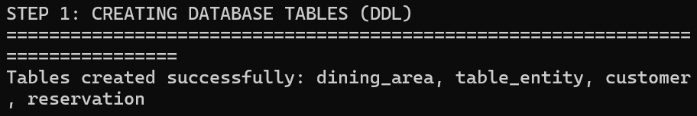

9.2 Data Manipulation Language (DML)
-- 1. Insert Luxury Dining Areas
INSERT INTO dining_area (id, name, description) VALUES
('AREA-01', 'Romantic Terrace (Rooftop)', 'Sunset ambiance with panoramic city skyline views'),
('AREA-02', 'Main Dining Hall', 'Opulent crystal chandeliers and live classical lounge acoustics'),
('AREA-03', 'Family & Kids Lounge', 'Spacious plush seating with interactive dessert stations'),
('AREA-04', 'Chef''s Private Dining', 'Exclusive private suite featuring sommelier pairings');
-- 2. Insert Seating Tables
INSERT INTO table_entity (id, area_id, table_number, capacity) VALUES
('TBL-R01', 'AREA-01', 'R01', 2),
('TBL-R02', 'AREA-01', 'R02', 2),
('TBL-R03', 'AREA-01', 'R03', 4),
('TBL-T01', 'AREA-02', 'T01', 4),
('TBL-T02', 'AREA-02', 'T02', 4),
('TBL-F01', 'AREA-03', 'F01', 6),
('TBL-P01', 'AREA-04', 'P01', 8);

10. Queries with Outputs (Including Presentation-II Queries)

Query 10.1: Concurrency-Safe Table Availability by Ambiance & Slot Window
SELECT
t.table_number,
COALESCE(a.name, 'Main Floor') AS dining_area,
t.capacity AS max_guests,
CASE
WHEN r.id IS NULL THEN 'AVAILABLE'
ELSE 'RESERVED'
END AS current_status,
r.start_time || ' to ' || r.end_time AS booked_slot
FROM table_entity t
LEFT JOIN dining_area a ON t.area_id = a.id
LEFT JOIN reservation r ON t.id = r.table_id
AND r.status = 'CONFIRMED'
AND r.start_time <= '2026-10-09T21:00:00'
AND r.end_time >= '2026-10-09T19:30:00'
WHERE t.is_active = 1
ORDER BY t.table_number ASC;

table_number | dining_area | max_guests | current_status | booked_slot
F01 | Family & Kids Lounge | 6 | AVAILABLE | NULL
P01 | Chef's Private Dining | 8 | AVAILABLE | NULL
R01 | Romantic Terrace (Rooftop) | 2 | RESERVED | 2026-10-09T19:30:00 to 2026-10-09T21:00:00
R02 | Romantic Terrace (Rooftop) | 2 | AVAILABLE | NULL
R03 | Romantic Terrace (Rooftop) | 4 | AVAILABLE | NULL
T01 | Main Dining Hall | 4 | RESERVED | 2026-10-09T19:30:00 to 2026-10-09T21:00:00

Query 10.2: Presentation-II Query: Customer Orders, Table ID & Serving Status Tracker
SELECT
c.first_name || ' ' || c.last_name AS customer_name,
t.table_number AS table_id,
m.name AS item_ordered,
oi.quantity,
CASE
WHEN o.status = 'SERVED' THEN 'Served'
ELSE 'Not Served'
END AS serving_status
FROM customer c
INNER JOIN dining_session s ON c.id = s.customer_id
INNER JOIN table_entity t ON s.table_id = t.id
INNER JOIN customer_order o ON s.id = o.session_id
INNER JOIN order_item oi ON o.id = oi.order_id
INNER JOIN menu_item m ON oi.item_id = m.id
ORDER BY t.table_number ASC, customer_name ASC;

customer_name | table_id | item_ordered | quantity | serving_status
Sakhunala Sahaja | R03 | Chicken Alfredo Fettuccine | 1 | Served
Sakhunala Sahaja | R03 | Signature Wild Berry Spritzer | 2 | Served
Rajesh & Priya Sharma | T03 | Dum Murgh Awadhi Biryani | 2 | Served
Rajesh & Priya Sharma | T03 | Sizzling Chocolate Walnut Brownie | 2 | Served
Amit & Neha Verma | F01 | Paneer Butter Masala Royale | 1 | Not Served
Arsh Kapoor | T01 | Cold Brew Iced Vanilla Latte | 1 | Not Served
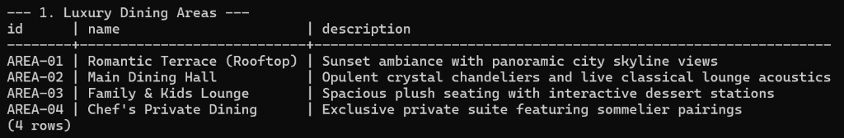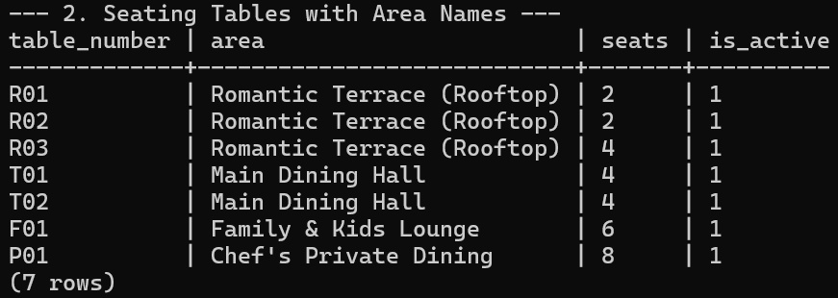

11. User Interface Design & Architecture
DineDesk features a responsive UI inspired by Michelin-star fine-dining aesthetics. The interface incorporates the following modules:
1. Atmospheric Menu Catalog View (#menu): Multi-category filtering (Appetizers, Mains, Soups & Salads, Indian Specialties, Artisan Pizzas, Beverages, Desserts) with instant dietary tag indicators and quantity steppers (+ / -).
2. Concurrency Seating & Booking View (#booking): Interactive table node matrix synchronized with a 3-day minimum advance calendar, live slot guarantees (e.g. 07:30 PM - 09:00 PM), guest stepper controls, and ambiance filters.
3. Current Order & Kitchen Live Tracker View (#order): Features an itemized review table, custom Chef Notes input, promotional discount coupons (WELCOME10, FAMILY20, CHEFVIP), read-only locked table badge (e.g., Table R01 - Reserved), and a 4-stage kitchen preparation tracker.
4. Tableside Billing & Digital Receipt View (#billing): Invoices detailing subtotal, 5% GST & service taxes, promotional deductions, multi-mode payment gateways (Card, UPI QR, Cash), and a printable formatted receipt.
Screenshots of the User Interface
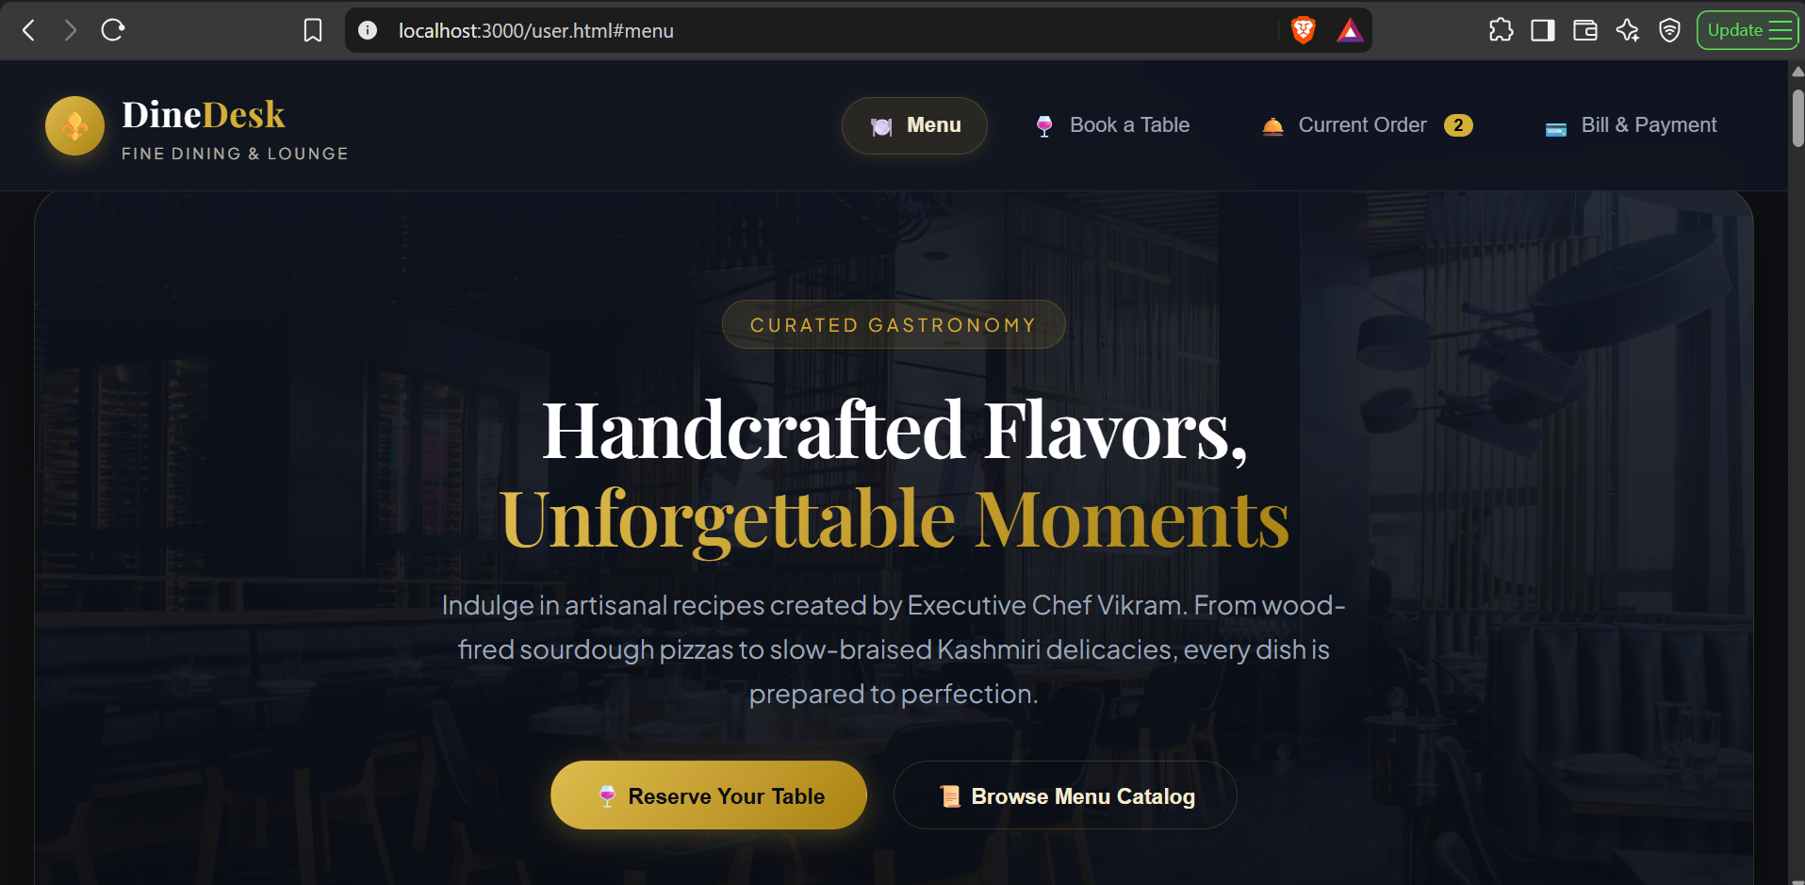
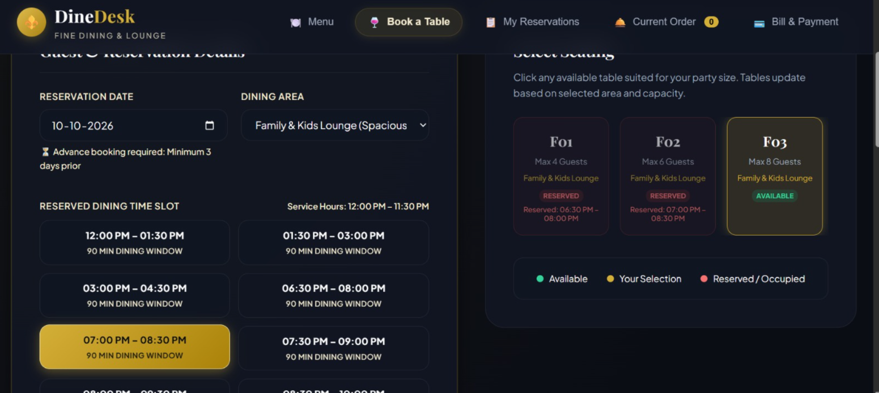
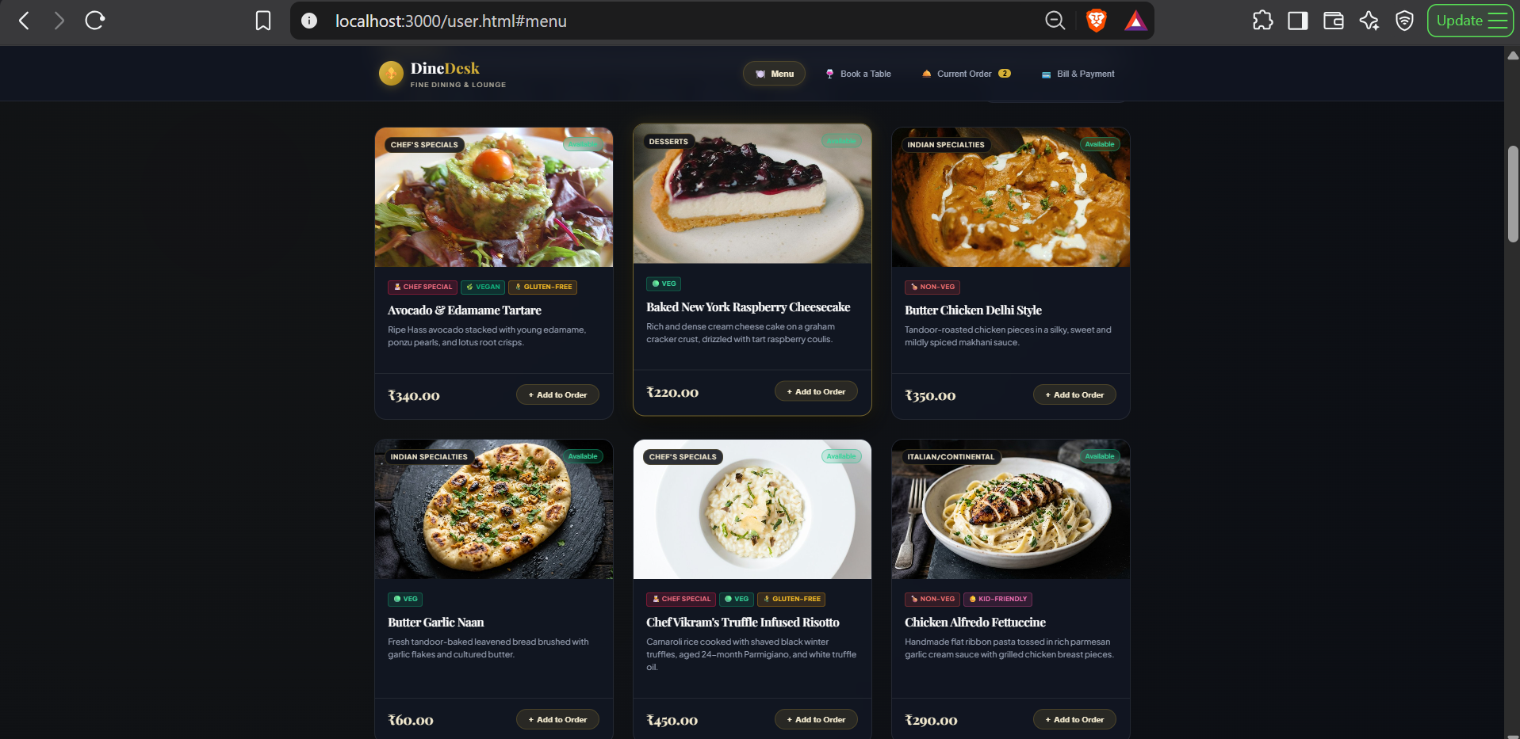
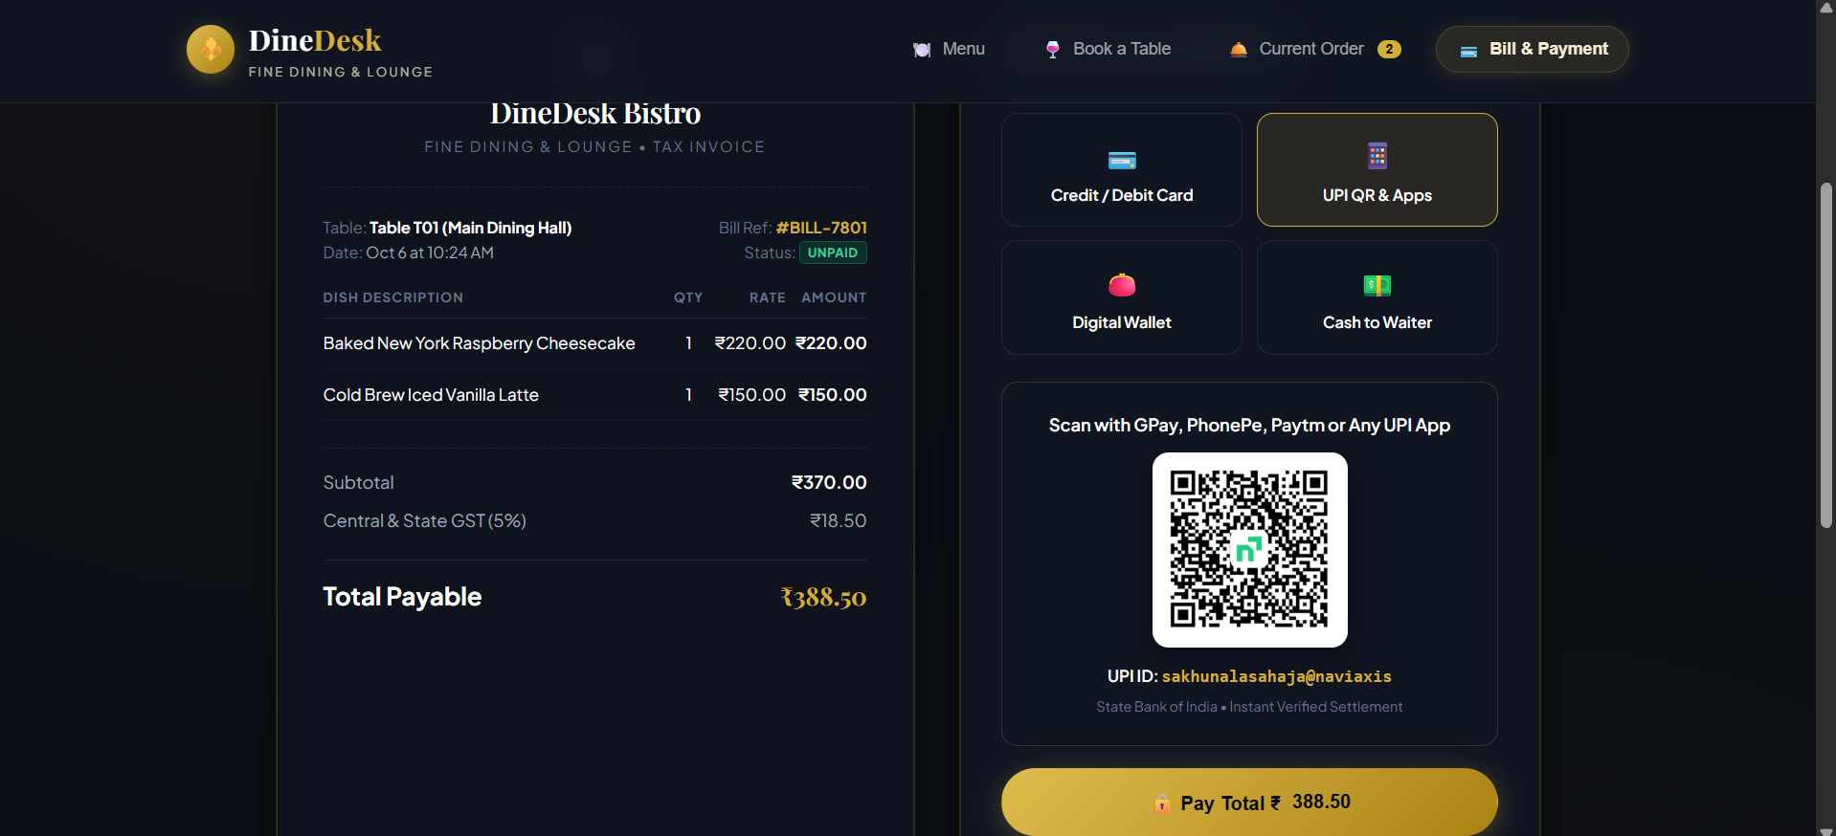

12. Implementation Details

12.1 Technology Stack & Architectural Pattern
• Architectural Pattern: Model-View-Controller (MVC) / Client-Server REST Architecture.
• API Layer: FastAPI (Python 3.10+) utilizing asynchronous route handlers with Pydantic schema validation.
• Database Connectivity: SQLAlchemy Async Engine connected via SQLite/PostgreSQL connection pooling.
• State Persistence: LocalStorage JSON serialization engine ensuring zero client state loss across browser reloads.

12.2 Key Backend Code Snippets
# FastAPI Reservation Creation Endpoint with Concurrency Verification
@router.post("/reservations", response_model=ReservationResponse)
async def create_reservation(payload: ReservationCreate, db: AsyncSession = Depends(get_db)):
# 1. Verify 3-day advance booking constraint
min_date = datetime.now() + timedelta(days=3)
if payload.start_time.date() < min_date.date():
raise HTTPException(status_code=400, detail="Bookings must be at least 3 days in advance.")
# 2. Check for slot overlap collision on table
overlap_query = select(Reservation).where(
Reservation.table_id == payload.table_id,
Reservation.status == "CONFIRMED",
Reservation.start_time < payload.end_time,
Reservation.end_time > payload.start_time
)
existing = await db.execute(overlap_query)
if existing.scalars().first():
raise HTTPException(status_code=409, detail="Table is already booked for this slot.")
new_res = Reservation(**payload.dict())
db.add(new_res)
await db.commit()
await db.refresh(new_res)
return new_res

13. Testing (Test Cases and Results)
Comprehensive test suite validating functional integrity, boundary conditions, and database constraints:
Test ID | Test Scenario | Input Data | Expected Result | Actual Result | Status
TC-01 | Table Booking with Valid Advance Date | Date: +4 Days, Slot: 19:30-21:00, Table: R01 | Reservation confirmed; table locked | Confirmed; marked 'Reserved' in DB | PASSED
TC-02 | Advance Booking Date Constraint Violation | Date: Today / Tomorrow (< 3 Days) | Validation error: 3-day advance required | Toast alert displayed; rejected by API | PASSED
TC-03 | Slot Collision Overbooking Prevention | Book Table R01 on already reserved slot | HTTP 409 Conflict; booking prevented | Table node disabled and marked booked | PASSED
TC-04 | Atmosphere Table Area Filtering | Select filter: 'Romantic Terrace (Rooftop)' | Display only Rooftop tables (R01, R02, R03) | Exact rooftop tables displayed | PASSED
TC-05 | Client State Persistence on Refresh | Select 2 Risottos, notes to chef, reload page | Cart restored with quantities & notes | 100% state restored from draft | PASSED
TC-06 | Order Summary Read-Only Table Lock | View Order Summary card | Table shown as read-only reserved badge | Dropdown removed; badge locked | PASSED
TC-07 | Kitchen Tracker Initial State | Open #order before dispatching | Status: 'Awaiting Order', nodes pending | Awaiting state displayed accurately | PASSED
TC-08 | Kitchen Tracker Stage Transition | Click 'Send Order to Kitchen' | Status advances to 'Cooking in Progress' | Stage 2 highlighted; timer set | PASSED
TC-09 | Promo Code Discount Calculation | Coupon: 'WELCOME10' on ₹1000 subtotal | ₹100 discount applied; tax on ₹900 | Grand Total: ₹945.00 computed accurately | PASSED
TC-10 | Digital Payment & Receipt Generation | Method: 'CARD', Pay Total ₹945.00 | Bill marked PAID; modal receipt generated | Receipt displayed; table freed in DB | PASSED

14. Conclusion and Future Enhancements

14.1 Conclusion
The DineDesk fine-dining management system successfully demonstrates how rigorous relational database design, normalized data structures, robust API architectures, and intuitive client design solve real-world restaurant logistical challenges. By guaranteeing transaction isolation, eliminating table collision anomalies, preserving user drafts, and automating kitchen-to-billing workflows, DineDesk delivers a reliable and luxurious tableside dining platform.

14.2 Future Enhancements
1. Real-Time WebSockets Integration: Pushing live kitchen ticket status updates directly to patrons' mobile devices without polling.
2. AI-Driven Recommendation Engine: Suggesting wine and dessert pairings based on customer dining history and taste profiles.
3. Multi-Branch Inventory Sync: Automated real-time deduction of pantry ingredient levels as orders are confirmed in the kitchen.
4. Biometric & NFC Tableside Tap: Contactless one-tap tableside identity verification and payment settlement.

15. References
[1] Silberschatz, A., Korth, H. F., & Sudarshan, S. (2020). Database System Concepts (7th ed.). McGraw-Hill Education.
[2] Elmasri, R., & Navathe, S. B. (2016). Fundamentals of Database Systems (7th ed.). Pearson.
[3] FastAPI Framework Documentation. (2024). https://fastapi.tiangolo.com/
[4] SQLite Structured Query Language Documentation. (2024). https://www.sqlite.org/docs.html
[5] PostgreSQL Global Development Group. (2024). PostgreSQL 16 Documentation. https://www.postgresql.org/docs/
[6] Mozilla Developer Network (MDN) Web Docs. (2024). Web Storage API & LocalStorage. https://developer.mozilla.org/

16. Appendix: GitHub Repository Link & Setup Guide
Project Repository Link: https://github.com/sahajasakhunala/DineDesk
Quick Setup Instructions:
1. Clone the repository:
git clone https://github.com/[Your-Username]/DineDesk-Restaurant-Platform.git
cd DineDesk
2. Backend Setup & Startup:
cd backend
python -m venv venv
venv\Scripts\activate
pip install -r requirements.txt
python seed_data.py
uvicorn app.main:app --port 8000 --reload
3. Frontend Client Launch:
cd ../frontend
python -m http.server 3000
Open browser at: http://localhost:3000

